Experiment No.06

nano pract6.c

CODE:

#include <stdio.h>
int main(){
int n,i;
int burst[20],waiting[20],turnaround[20];
float avg_wait=0,avg_turn=0;
printf("Enter number of processes: ");
scanf("%d",&n);
printf("Enter Burst Time for each process:\n");
for(i=0;i<n;i++){
printf("P%d: ",i+1);
scanf("%d",&burst[i]);
}
waiting[0]=0;
for(i=1;i<n;i++){
waiting[i]=waiting[i-1]+burst[i-1];
}
for(i=0;i<n;i++){
turnaround[i]=waiting[i]+burst[i];
avg_wait+=waiting[i];
avg_turn+=turnaround[i];
}
printf("\nProcess\tBurst Time\tWaiting Time\tTurnaround Time\n");
for(i=0;i<n;i++){
printf("P%d\t%d\t\t%d\t\t%d\n",i+1,burst[i],waiting[i],turnaround[i]);
}
printf("\nAverage Waiting Time = %.2f",avg_wait/n);
printf("\nAverage Turnaround Time = %.2f\n",avg_turn/n);
return 0;
}

OUTPUT:
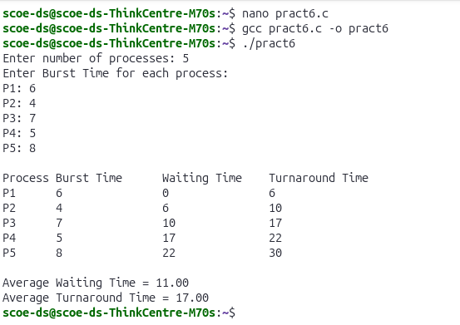
AIM
To write a program to demonstrate the concept of Non-Preemptive Scheduling Algorithm
(FCFS – First Come First Serve).
RESOURCES REQUIRED
Ubuntu Operating System
Terminal
Text Editor (nano)
GCC Compiler
THEORY
In Operating Systems, CPU scheduling decides which process gets the CPU for execution.
In Non-Preemptive Scheduling, once a process starts execution, it continues until it finishes
or enters the waiting state. The CPU is not taken away from the process until it completes.
One of the simplest non-preemptive scheduling algorithms is FCFS (First Come First Serve).
FCFS schedules processes in the order they arrive.
Characteristics of FCFS:
Simple and easy to implement.
Uses FIFO (First In First Out) queue.
Non-preemptive in nature.
May cause convoy effect (short processes wait behind long processes).
Important Terms:
Arrival Time (AT) – Time at which process enters ready queue.
Burst Time (BT) – CPU time required by process.
Completion Time (CT) – Time at which process finishes.
Turnaround Time (TAT) = CT – AT.
Waiting Time (WT) = TAT – BT.

CONCLUSION
Thus, the program for Non-Preemptive Scheduling (FCFS) was successfully implemented.
The waiting time and turnaround time were calculated for each process. This experiment
demonstrates how processes are scheduled in First Come First Serve order without
interrupting the currently running process.

